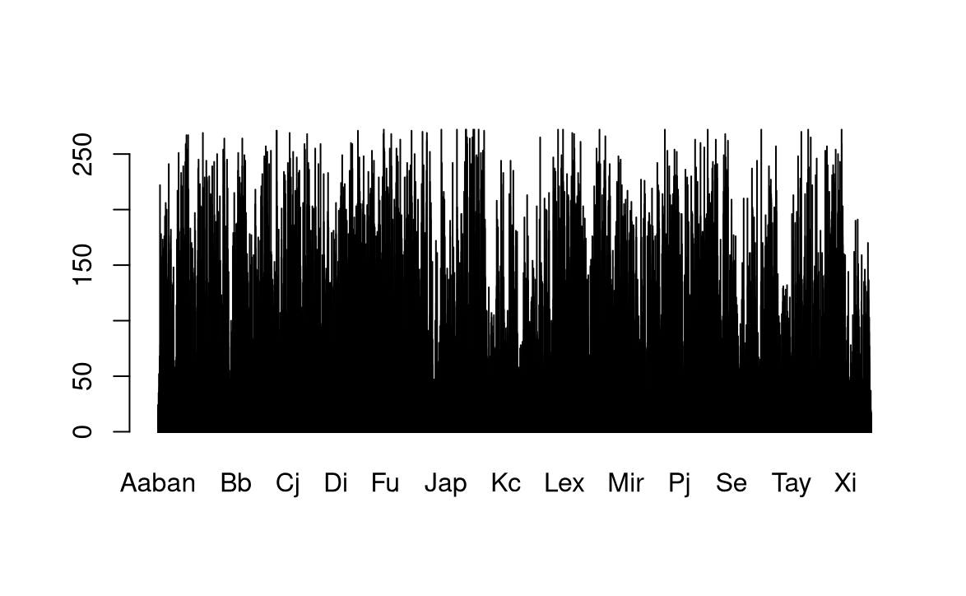

This bar chart describes the number of babies with the same name.

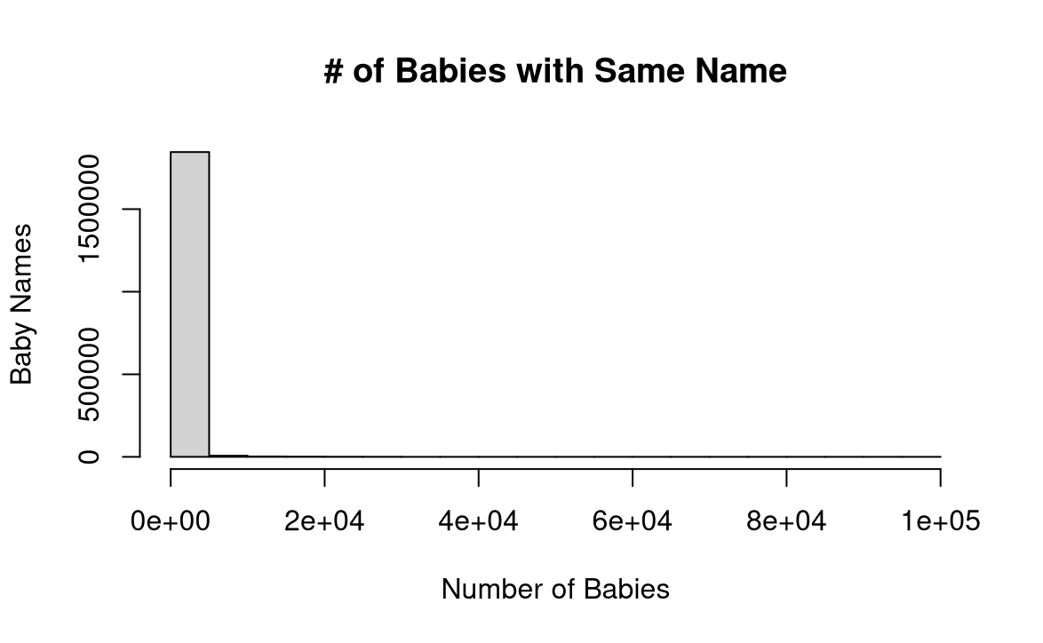

As we can see, this bar chart is skewed to the right.

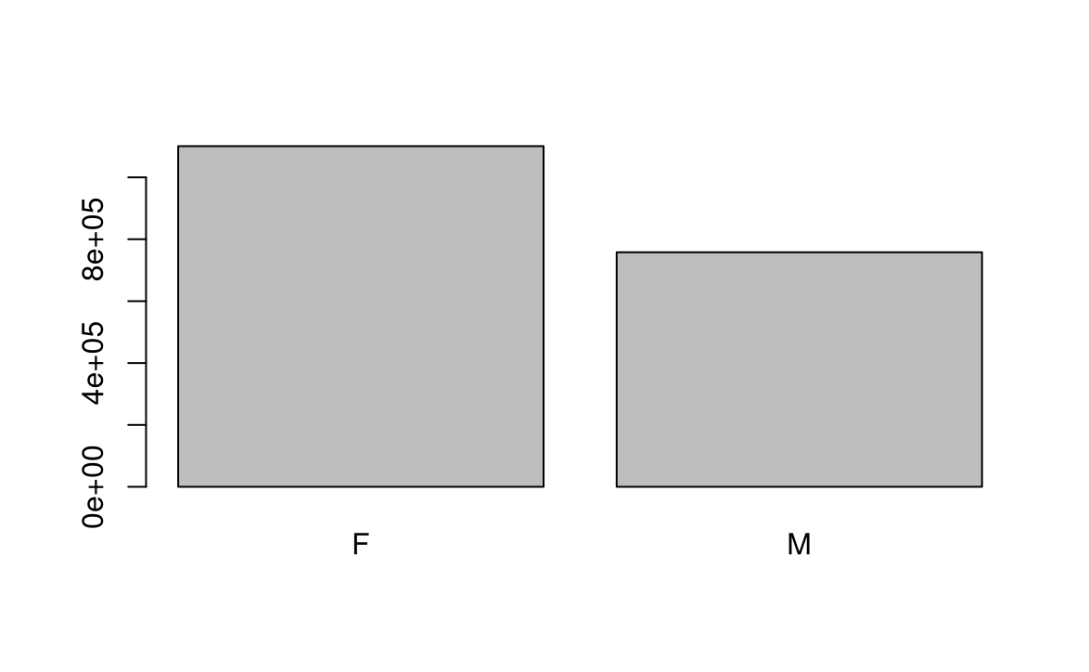

This bar chart compares the amount of female and male on the study.

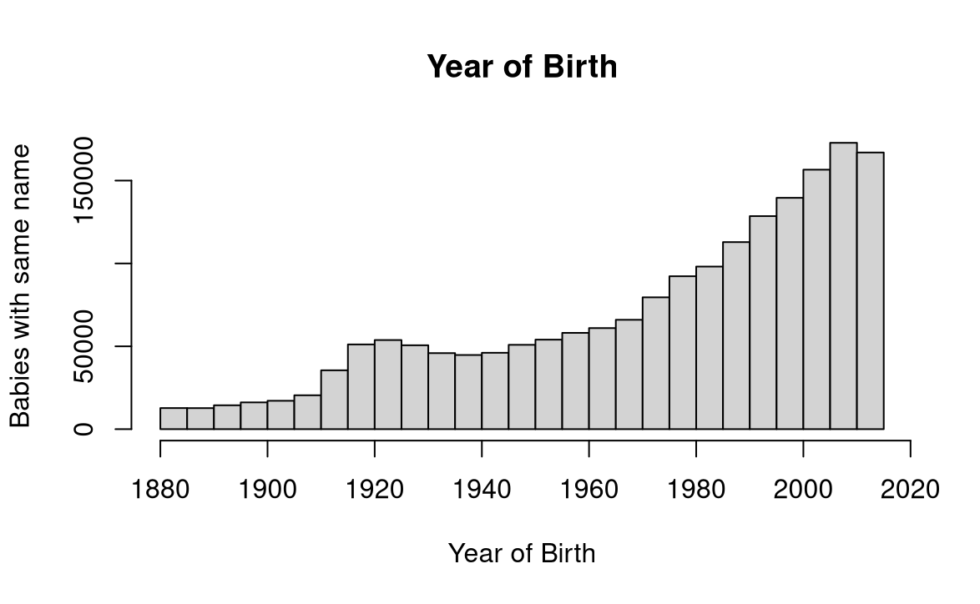

This bar chart is skewed to the left. It shows us that in the recent years more babies have had the same names.